October 2, 2020 9:19am PT

# [Chris Meloni ‘Law & Order: SVU’ Spinoff Delayed as Showrunner Exits](https://variety.com/2020/tv/news/chris-meloni-law-order-svu-spinoff-delayed-as-showrunner-exits-1234790563/amp/?__twitter_impression=true)

**By** [**Will Thorne**](https://variety.com/author/will-thorne/)

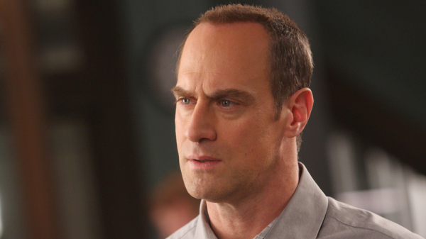

Universal Television

The “Law & Order: SVU” spinoff centering around Chris Meloni’s Elliot Stabler has been delayed.

The news comes as a result of a showrunner change, with Matt Olmstead exiting the role for creative reasons, *Variety* has confirmed with sources. Olmstead has plenty of history in the Dick Wolf stable of shows, having co-created and helped launch “Chicago P.D.,” “Chicago Med,” and “Chicago Fire.”

“Law & Order: Organize Crime” was previously scheduled to premiere on NBC in the fall, however, back in August it was nowhere to be seen in a [revised fall schedule](https://variety.com/2020/tv/news/this-is-us-season-5-premiere-date-nbc-fall-schedule-1234751318/) issued by the network. Sources say it is still on course to air sometime in the 2020-2021 season, which is being heavily disrupted by the coronavirus pandemic. It will now begin a search for a new showrunner, with Olmstead likely to move to a different Wolf property, sources say.

The showrunner change is not the first time “Law & Order: Organize Crime” has made headlines, as Wolf himself stepped in to [fire writer Craig Gore from the series](https://variety.com/2020/tv/news/dick-wolf-craig-gore-fired-law-and-order-spinoff-controversial-facebook-posts-1234623190/) back in June, after Gore posted controversial Facebook posts about looters and the COVID-19 curfew in Los Angeles.

### Popular on Variety

The show itself will follow Stabler as he heads up the organized crime division of the NYPD. It brings Meloni back into the Dick Wolf fold for the first time since he left “SVU” in the show’s 12th season back in 2011. Meloni departed the show at the end of Season 12, so it was written into the Season 13 premiere that Stabler had retired from the police force.

As for the original “SVU,” that series is still on schedule for a Nov. 12 premiere on NBC, only a day after the trio of “Chicago” dramas.

Other than Wolf, “Organized Crime” is being executive produced by Fred Berner, Terry Miller, Arthur W. Forney and Peter Jankowski.

*The Hollywood Reporter* first broke the news.